Discussion Question: 100 Things
Using the 100 Things Every Designer Should Know About People reading assignment, select two (2) of the "things" you read about. In your post, include the number and title of the "thing" (i.e. #36 Time is Relative) and then do two embellishments, one embellishment and one visual example, or two visual examples.
- Embellish: Tell us something that the reading did not tell us on that specific "thing" or embellish on what was presented. Be sure you are adding meaningful content to the conversation and not just making noise. Your addition can be a link to an article or you can write out your embellishment.
- Visual Example: Provide us with a graphic example that is relevant to web design. This can be something you create or something you find. Again, be sure to add meaningful content to the conversation.
85-92

For my first topic of embellishment, I will focus on Topic 85: People Will Always Make Mistakes; There Is No Fail-Safe Product. In 2023, Jacob Gruver, on the Medium website, addressed how to enhance UI design through error handling. An effective UI anticipates mistakes, provides relevant information to the user, draws the user’s attention to any errors or potential ones, and is designed to prevent errors in the first place (Gruver, 2023)

Because people will always make mistakes, building interfaces that are more forgiving of user errors is best practice. Our text includes information on including error messages for users, but there are even more ways to make the error code more efficient. If a tiny mistake reloads an entire form and makes a person start from scratch instead of just fixing where the error occurred, they may be less likely to abandon the site entirely.
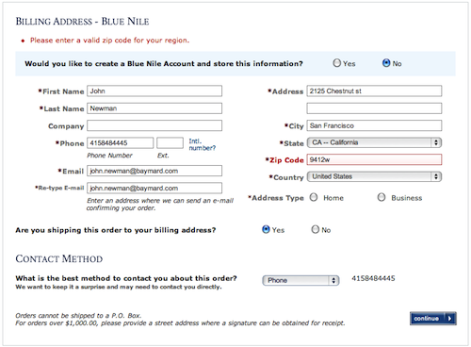
My second topic of embellishment is Topic 86: People Make Errors When They Are Under Stress. In Stephen Gossett’s 2022 article, he discusses ways to make the user interface experience less stressful. Some ways to make the UI more familiar and decrease the user’s likelihood of making mistakes is by following standard layouts and using symbols or buttons that are easily recognizable (Gossett, 2022)
Since users may be more likely to click off a website or completely get off their device if they feel too stressed, sending a follow-up email is a way to get them to return later. Emails like the screenshot below are a good way to remind users of their previous online activity and potentially prompt them to continue their journey at another less stressful time.
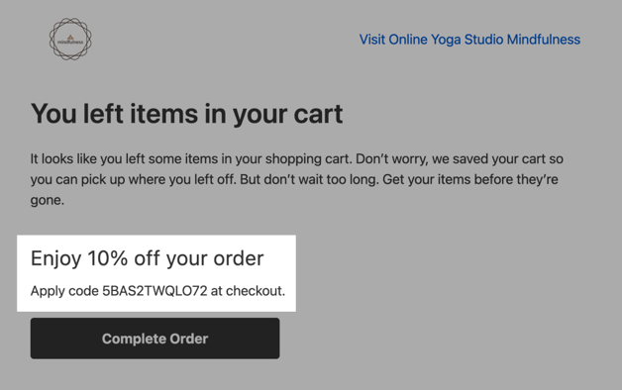

References
Gossett, S. (2022, February 9). Smart UX Design Can Reduce Stress For Users | Built In. Built In. https://builtin.com/articles/life-and-death-design
Gruver, J. (2023, October 23). Enhancing UX/UI Design through Effective Error Handling. Medium. https://medium.com/@jgruver/enhancing-ux-ui-design-through-effective-error-handling-f4bedc1edd8c

Before you submit your thread, put your name in the subject line.

Assignment Requirements and Grading:
- An initial post of approximately 250 words is due by Thursday, 11:59 p.m., CST.
- For the initial post to be considered substantive, it should be at least 250 words in length and fully cover the topics being presented. Single-sentence definitions or responses will not be awarded points.
- Submit your post by clicking on the Assignment Link above, then Create Thread. You must create a thread in order to view your peers' posts. Tip: Create your post in a Word document and then copy and paste your work into the thread.
- A minimum of three (3) responses, to the original threads of other students, of 100-200 words each are due by Sunday, 11:59 p.m., CST.
- To view the rubric grading criteria, click on the following link: Discussion Board Grading Rubric.
(50 points)

